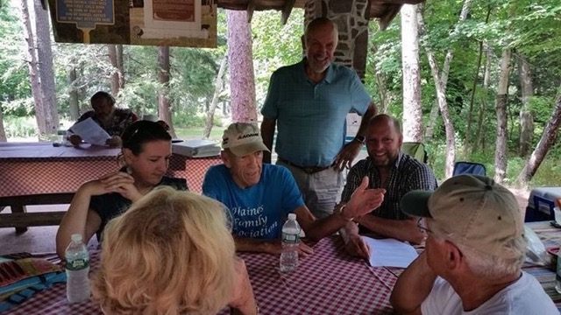

Haines Family Association, Inc.

[www.hainesfamilyassociation.org](http://www.hainesfamilyassociation.org)

**31st ANNUAL FAMILY REUNION   
PICNIC & MEETING**

South Lake Pavilion

Saturday, August 26, 2017

Haines Family Members and Friends,

This year’s theme is inclusion; we need next generation family members to join the fun and share in their family’s storied history. This year we will be celebrating our 31st annual family reunion and meeting, so let’s get together and celebrate our fortune. This year marks 238 years of the Haines family being on the mountaintop-a rugged climb, and a life eked out of whittles and bores. This year’s reunion will be held at the North Lake pavilion on Saturday, August 26, starting at 11am at the North - South Lake State Park. As always, all are welcome. It’s a celebration, so make it a point to **come** meet with family, friends, and neighbors to enjoy a beautiful day in the Catskills

There are plenty of activities to fill your time with throughout the day if catching up, eating and cheer becomes tiresome. There are short hikes to incredible scenic vistas and longer ones that also take your breath. The lake itself provides swimming, boating, and fishing for all sorts of water enthusiasts. The beaches at both North and South Lake have lifeguards on duty that add a level of security for us parents and grandparents who understand that our little ones could use an extra set of eyes to look out for their safety. If you want to strap a bicycle to your car, there are miles of roads and trails for your amusement. Bring a Frisbee, volleyball, or whiffle ball and bat and head to the field a short walk away for some good old-fashioned fun. The outdoors is at your disposal.

Once again, this year the Board of Directors will provide the protein for the picnic’s culinary diet in addition to Stewart’s ice cream. Instead of bring your own lunch, we will provide hamburgers, hotdogs, sausages, and chicken-you provide a side dish to pass and beverages of your choosing. However, there is one caveat, we just need an estimated head count so we know how much food to supply. What’s a party without people? **RSVP** to President Anthony Coiro at [coiroanthony@yahoo.com](mailto:coiroanthony@yahoo.com) Phone: 518-589-7196, or Gibby Van Dyke, Vice-President at [gvd.contracting@icloud.com](mailto:gvd.contracting@icloud.com) Phone: 908-285-0145 **by August 20**, 2017. Remember, the reunion picnic is a time for family and friends to get together and enjoy the bonds we share. Bring photos and whatever you know about your family tree, and hopefully some of our attendees can further add to your knowledge

**News**: 2016-17 has been a busy time. We had work parties for cleanup and maintenance at the Aaron Haines, Peter B. Haines and Layman cemeteries. In addition, a work party also completed trash pickup along the Haines section of the Adopt-A- Highway program on Route 23A

In late July, the Haines Family Association had an exhibit and cemetery tours at the Mountain Top Historical Society’s *Local History Day.* Additionally, our volunteer HFA groundskeepers and mowing crew have been busy keeping things looking great at the Mountain Top Historical Society.

**Membership Dues and Donations**

As you all know, community support and service does not come without a price tag. That is why your continued support is needed if we wish to provide our services to the mountaintop communities. Although our dues remain only $5 per year, the generous support given through your donations allows us to reach out where there is need. You can mail your dues and donations, or hand them in at the reunion. We need updated email addresses so we can send out information without spending dues money on postage and supplies. We are also looking to add members of families to our database so we can keep our reunion going for years to come. Please provide updated contact info for your children/heirs for inclusion.

**Annual Board of Directors Meeting**

On July 8, 2017 the Board of Directors met at the Mountain Top Historical Society to cover new and old business and to put forward the slate of officers and directors. At this time, we would like to thank Robert (Bob) Van Dyke for his many years of service to the Board of Directors. If you have questions or comments, check out our newsletters, activity updates, or contact any of our officers or directors on our website at [www.hainesfamilyassociation.org](http://www.hainesfamilyassociation.org).

**Tentative slate of Officers and Directors** for 2016-2017 is as follows: President – Anthony Coiro, Vice President/Treasurer George “Gibby” Van Dyke Jr., Secretary - Richard E. Haines, and Directors: Nancy McGowan, Linda Schultz, Harriet Bucca, George Van Dyke Sr., Sandy Palmer, Harold Palmer, Peg Fries, Robert Haines, Sarah Van Dyke and Aaron Van Dyke. If you would like to nominate someone, let us know now, or at our annual reunion meeting.

I hope to see all of you at our reunion barbeque picnic on Saturday, August 26 at the South Lake pavilion!

Sincerely,

Anthony Coiro

President

Haines Family Association, Inc.