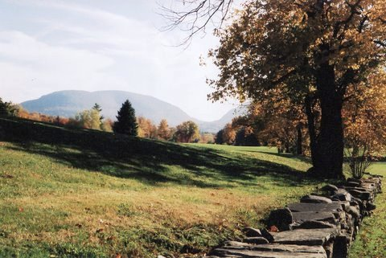
Mink Hollow, through which the first Haines settlers journeyed to arrive on
the mountaintop.
Haines Family Association, Inc.
www.hainesfamilyassociation.org

TWENTY-NINTH ANNUAL FAMILY REUNION
& MEETING
Dolans Lake Pavilion on Ski Bowl Road in Hunter, NY
Saturday, July 11, 2015

Hello All Haines Family Members and Friends,

NEWS: OUR ANNUAL REUNION WILL BE HELD AT THE DOLAN’S LAKE PAVILION ON SKI BOWL ROAD IN HUNTER THIS YEAR! July 11th, 2015 will be our 29th annual family reunion and meeting. We will be celebrating 236 years of Haines families on the mountaintop. All are welcome, so bring family and friends! This is a time for descendents of the mountaintop settlers and friends to get together and reminisce about their ancestors and current family. Bring photos and whatever you know about your family tree, and hopefully some of our attendees can add info to it. We will have activities for the youngsters, and a table where you can share your special dish or treat or snacks. Ice cream is again being donated by the Haines Falls Stewarts Shop for us to enjoy. If you’d like to share your favorite recipes, bring them with you - especially old family favorites! If you would like to bring the finished item for attendees to sample, all the better!
2014 was a busy year. We had work parties for cleanup, repairs, maintenance and mowing at the Aaron Haines cemetery. However, the weather did not cooperate on days we planned cleanup work at the Peter B. Haines and Layman cemeteries. Work parties also completed trash pickup along our Adopt-A-Highway section in May and September, with additional spot cleanup in July and August as HFA members noticed trash along the highway. Thank you to HFA board members and their families for helping at these work parties.
Our volunteer HFA groundskeepers and mowing crew were busy at the Mountain Top Historical Society again in 2014, and are already working there again in 2015. If you have some spare time – part of a day or a whole day – and like to use a riding mower, let us know.
2015: We started off with a work party on May 16th for the highway cleanup along our adopted section of Route 23A in the town of Hunter. We have plans for future highway cleanup work crews for July or August, and again in September, as needed by the conditions. Cemetery work parties have begun, with the first being the mowing of the Aaron Haines Cemetery. More are being planned for future dates. Let us know if you are able to help.
Membership dues and donations are needed to continue our services to the mountaintop communities.
Our dues are only $5 per year, which does not go far; that is why we ask for donations. You can send your dues and donations by mail, or hand them in at the reunion. When you send in your dues, please include your updated email address so we can send out info without spending dues money on postage and supplies.
We held our annual Board of Directors meeting on May 16, 2015. You can see our previous and current newsletters and activity updates, or contact any of our officers or directors, on our website at www.hainesfamilyassociation.org.
Our tentative slate of Officers and Directors for 2015-2016 is as follows: President - Tony Coiro, Vice President - George “Gibby” Van Dyke Jr., Secretary - Richard E. Haines, Treasurer - George “Gibby” Van Dyke Jr., and Directors: Nancy McGowan, Robert H. Van Dyke, Linda Schultz, Harriet Bucca, George Van Dyke Sr., Sandy Palmer, Harold Palmer, Peg Fries, Robert Haines, Jim Jones. If you would like to nominate someone, let us know, either now or at our annual reunion / meeting.
Thank you. I’m looking forward to visiting with you at Dolans Lake Pavilion on Ski Bowl Road in Hunter NY on July 11th!
Sincerely,

Harold Palmer
President
Haines Family Association, Inc.
(607) 638-9013

From Sandy Palmer, HFA webmaster: Our website www.hainesfamilyassociation.org is growing and very active. There is a great deal of ancestry and other info posted, along with family trees with beautiful ancestry photos! To have your tree included, send the info to webmaster@hainesfamilyassociation.org . You can privately view your page as it is being built to offer suggestions. Guidelines for submission are at http://hainesfamilyassociation.org/descendants.html .
Haines Family Association is also on FaceBook! Find us at www.facebook.com/HainesFamilyAssociationInc. Did you know you can participate on our page? It’s easy! Here are some ways to take part:
- Just visit our page and click “LIKE” – it’s just below the picture that’s at the top of the page.
- When we post new things, write a comment or click “like” below the post. This tells Facebook that people are interested in what we have to say!
- If you have news and/or photos you can share, please feel free to post on our page!
- If you’d prefer, or if you don’t have a Facebook account, send info/photos for posting to webmaster@hainesfamilyassociation.org .
We hope you will visit our website, and take part in our Facebook page. See you at the reunion at DOLAN’S LAKE PAVILION ON SKI BOWL ROAD IN HUNTER!!!

Sincerely,
Sandy.

